**Michael Scott Walker**

**Option 1**

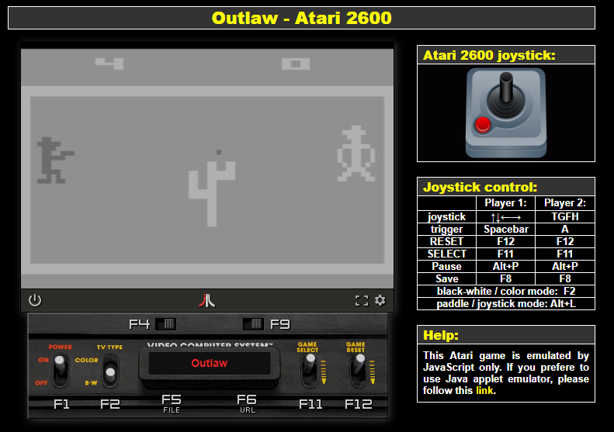

**From Wikipedia.**

Outlaw simulates an old west fast draw duel between the player and the computer.

The objective being to fast draw your gun as soon as he draws his. Shooting the other player before he shoots you scores points.